Pizza Orders Data Analysis using SQL

**Q1) Retrieve the total number of orders placed**

SQL Query:

SELECT

COUNT(order_id) AS Total_Orders

FROM

orders;

Result:

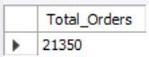

**Q2) Calculate the total revenue generated from pizza sales**

SQL Query:

SELECT

ROUND(SUM(orders_details.quantity * pizzas.price),

2) AS total_sales

FROM

orders_details

JOIN

pizzas ON pizzas.pizza_id = orders_details.pizza_id;

Result:

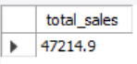

**Q3) Identify the highest priced prizza**

SQL Query:

SELECT

pizza_types.name, pizzas.price

FROM

pizza_types

JOIN

pizzas ON pizza_types.pizza_type_id = pizzas.pizza_type_id

ORDER BY pizzas.price DESC

LIMIT 1;

Result:

**Q4) Identify the most common pizza size ordered**

SQL Query:

SELECT

pizzas.size,

COUNT(orders_details.order_details_id) AS order_count

FROM

pizzas

JOIN

orders_details ON pizzas.pizza_id = orders_details.pizza_id

GROUP BY pizzas.size

ORDER BY order_count DESC;

Result:

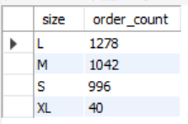

**Q5) List the top 5 most ordered pizza types along with their quantities**

SQL Query:

SELECT

pizza_types.name, SUM(orders_details.quantity) AS quantity

FROM

pizza_types

JOIN

pizzas ON pizza_types.pizza_type_id = pizzas.pizza_type_id

JOIN

orders_details ON orders_details.pizza_id = pizzas.pizza_id

GROUP BY pizza_types.name

ORDER BY quantity DESC

LIMIT 5;

Result:

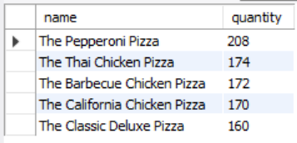

**Q6) Join the necessary tables to find the total quantity of each pizza category ordered**

SQL Query:

SELECT

pizza_types.category,

SUM(orders_details.quantity) AS quantity

FROM

pizza_types

JOIN

pizzas ON pizza_types.pizza_type_id = pizzas.pizza_type_id

JOIN

orders_details ON orders_details.pizza_id = pizzas.pizza_id

GROUP BY pizza_types.category

ORDER BY quantity DESC;

Result:

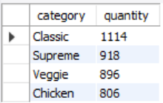

**Q7) Determine the distribution of orders by hour of the day**

SELECT

HOUR(order_time) AS hour, COUNT(order_id) AS order_count

FROM

orders

GROUP BY HOUR(order_time);

Result:

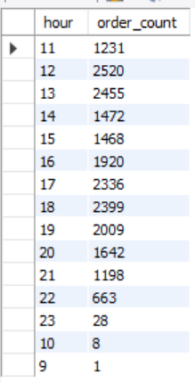

**Q8) Join relevant tables to find the category-wise distribution of pizzas**

SQL Query:

SELECT

category, COUNT(name)

FROM

pizza_types

GROUP BY category;

Result:

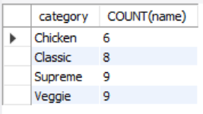

**Q9) Group the orders by date and calculate the average number of pizzas ordered per day**

SQL Query:

SELECT

ROUND(AVG(quantity), 0)

FROM

(SELECT

orders.order_date, SUM(orders_details.quantity) AS quantity

FROM

orders

JOIN orders_details ON orders.order_id = order_details_id

GROUP BY orders.order_date) AS order_quantity;

Result:

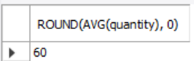

**Q10) Determine the top three most ordered pizza types based on revenue**

SQL Query:

SELECT

pizza_types.name,

SUM(orders_details.quantity * pizzas.price) AS revenue

FROM

pizza_types

JOIN

pizzas ON pizzas.pizza_type_id = pizza_types.pizza_type_id

JOIN

orders_details ON orders_details.pizza_id = pizzas.pizza_id

GROUP BY pizza_types.name

ORDER BY revenue DESC

LIMIT 3;

Result:

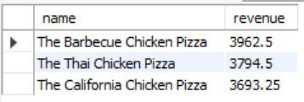

**Q11) Calculate the percentage contribution of each pizza type to total revenue**

SQL Query:

SELECT

pizza_types.category,

ROUND(SUM(orders_details.quantity * pizzas.price) / (SELECT

ROUND(SUM(orders_details.quantity * pizzas.price),

2) AS total_sales

FROM

orders_details

JOIN

pizzas ON pizzas.pizza_id = orders_details.pizza_id) * 100,

2) AS revenue

FROM

pizza_types

JOIN

pizzas ON pizza_types.pizza_type_id = pizzas.pizza_type_id

JOIN

orders_details ON orders_details.pizza_id = pizzas.pizza_id

GROUP BY pizza_types.category

ORDER BY revenue DESC;

Result:

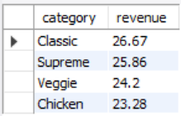

**Q12) Analyze the cumulative revenue generated over time**

SQL Query:

select order_date,

sum(revenue) over(order by order_date) as cum_revenue

from

(select orders.order_date,

sum(orders_details.quantity*pizzas.price) as revenue

from orders_details join pizzas

on orders_details.pizza_id=pizzas.pizza_id

join orders

On orders.order_id=orders_details.order_id

group by orders.order_date) as sales;

Result:

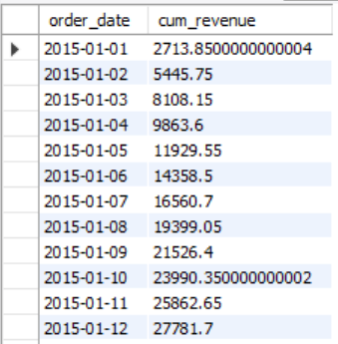

**Q13) Determine the top 3 most ordered pizza types based on revenue for each pizza category**

SQL Query:

select name, revenue from

(select category, name, revenue, rank() over(partition by category order by revenue desc) as rn

from

(select pizza_types.category,pizza_types.name,

sum((orders_details.quantity)*pizzas.price) as revenue

from pizza_types join pizzas

on pizza_types.pizza_type_id=pizzas.pizza_type_id

join orders_details

on orders_details.pizza_id=pizzas.pizza_id

group by pizza_types.category,pizza_types.name) as a) as b

where rn<=3;

Result:

